Pizza Sales Projects using Excel, MySQL and Power Bi Codes

1. Calculating Total Revenue

SELECT sum(total_price) As Total_revenue FROM pizza_sales.pizza_sales;

Output

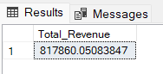

1. Calculating Average order Value

SELECT sum(total_price)/count(distinct order_id) AS Average_Order_Value  FROM pizza_sales.pizza_sales;

Output

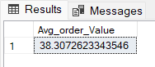

1. Calculating Total Pizzas Sold

SELECT sum(quantity)  As Total_Pizzas_Sold FROM pizza_sales.pizza_sales;

Output

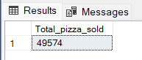

1. Calculating Total orders

SELECT COUNT(DISTINCT order_id) AS Total_Orders

FROM pizza_sales.pizza_sales;

Output

1. Calculating Average Pizzas Per Order

SELECT

ROUND(SUM(quantity) / COUNT(DISTINCT order_id), 2) AS Average_Pizzas_Per_Order

FROM

pizza_sales.pizza_sales;

Output

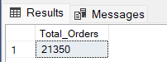

1. **Average Pizzas Per Order**

SELECT

ROUND(SUM(quantity) / COUNT(DISTINCT order_id), 2) AS Avg_Pizzas_per_order

FROM

pizza_sales.pizza_sales;

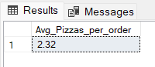

**B. Daily Trend for Total Orders**

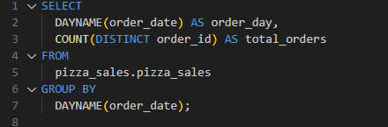

***Output:***

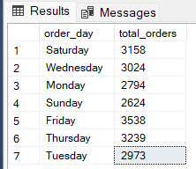

**C. Monthly Trend for Orders**

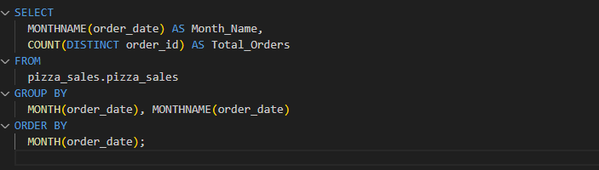

***Output***

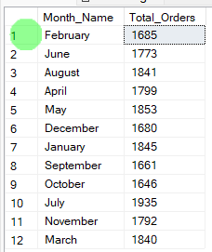

**D. % of Sales by Pizza Category**

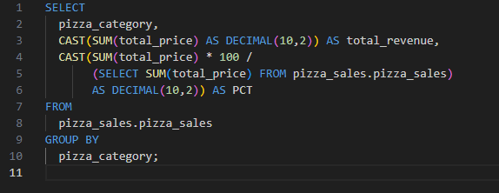

**OUTPUT**

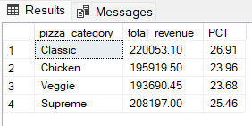

**E. % of Sales by Pizza Size**

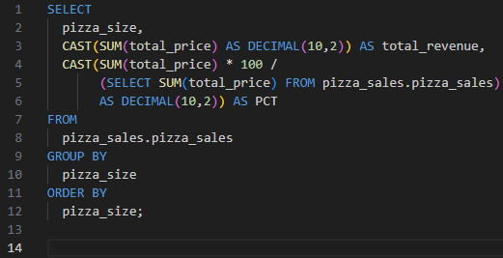

***Output***

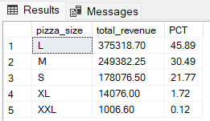

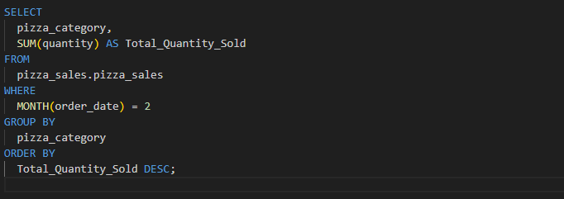***Output***

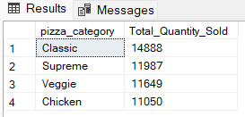

**G. Top 5 Pizzas by Revenue**

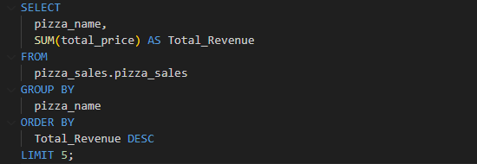

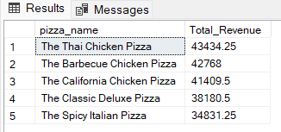

**H. Bottom 5 Pizzas by Revenue**

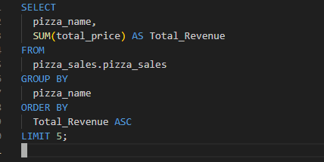

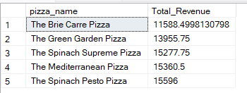

**I. Top 5 Pizzas by Quantity**

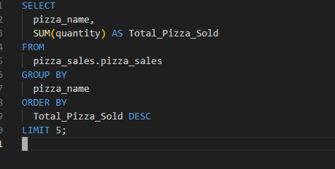***Output***

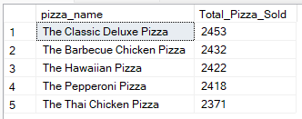

**J. Bottom 5 Pizzas by Quantity**

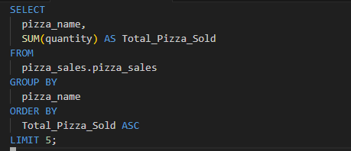

***Output***

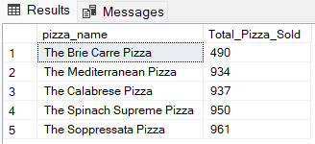

**K. Top 5 Pizzas by Total Orders**

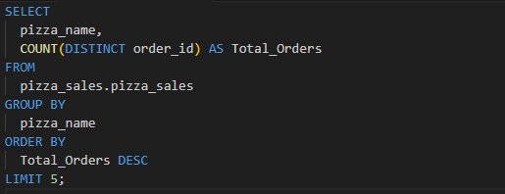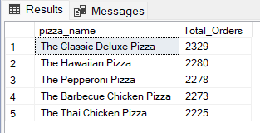

**L. Bottom 5 Pizzas by Total Orders**

